David Olson

Project 2 Whiteboard Experience

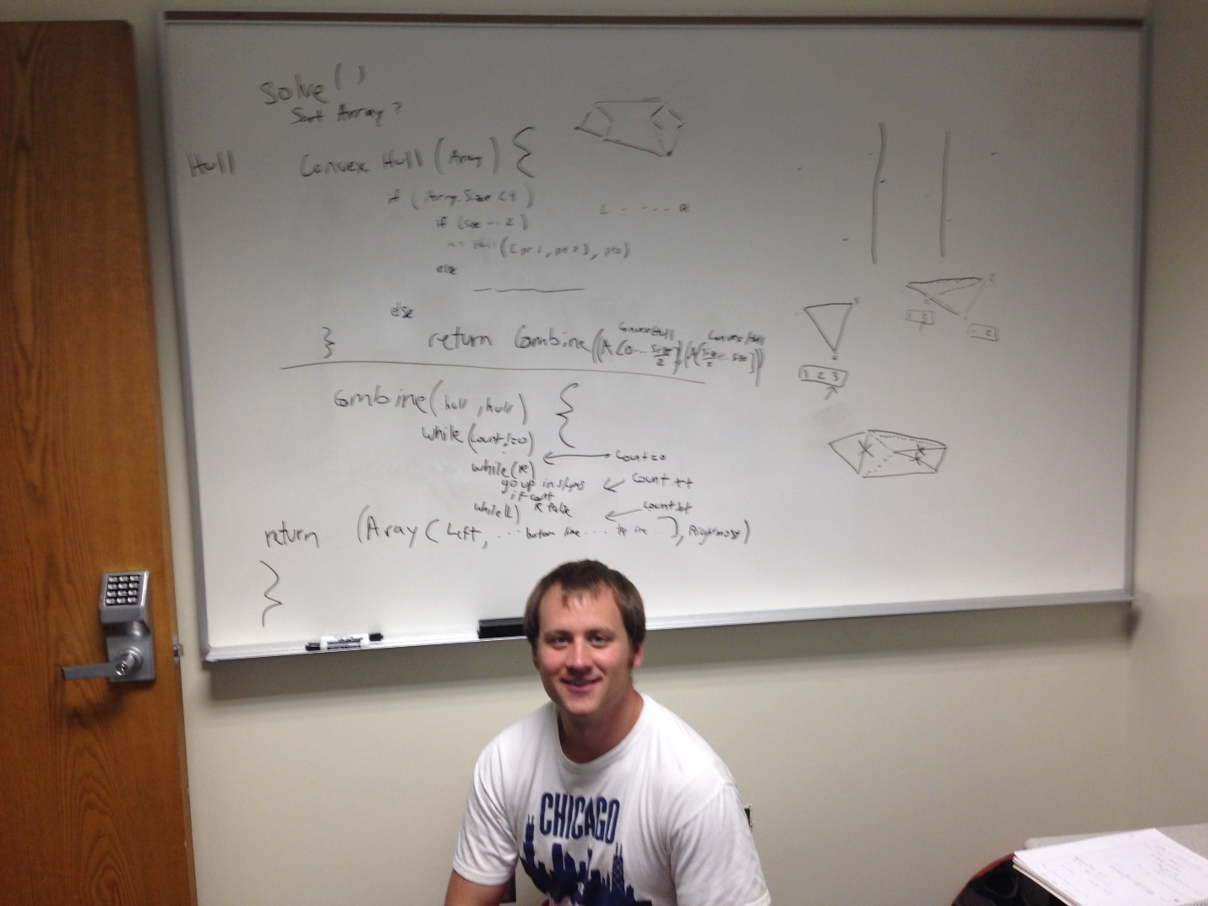

The left of the whiteboard contains the functions that I will use for the bulk of project 2. Solve is called by the code we are given, and that sends an array of points into a recursive function called convexHull. That function eventually breaks down the array into smaller ones of size 2 or 3, then combines results in the combine function. The combine function is tricky, but my 312 classmate and I came to a solution that uses a few while loops, a couple Booleans, and a count to find the top and bottom edge of the new hull. The function also correctly puts the correct points in the new hull, and returns a rightmost point.

On the right hand of the board I drew some sample points and pictorially worked through the algorithm as I was explaining my functions.

Below the whiteboard you will find me, unknowingly braced in an awkward pose.